Andree Salvo
Southern New Hampshire University
CYB 310 – 7-2 Project Three Submission: Restructuring Status Report
Instructor: Raschid Muller

- Network Reconfiguration
- Network Diagram
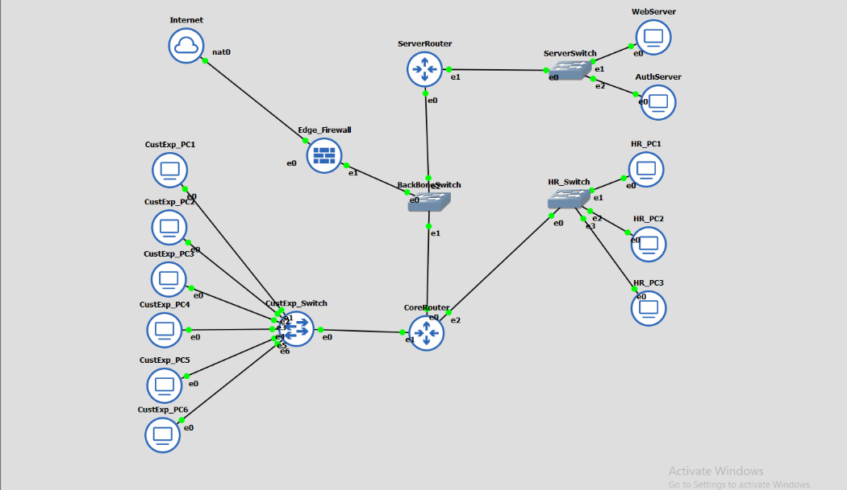
- Port assignment and VLAN assignment for each switch
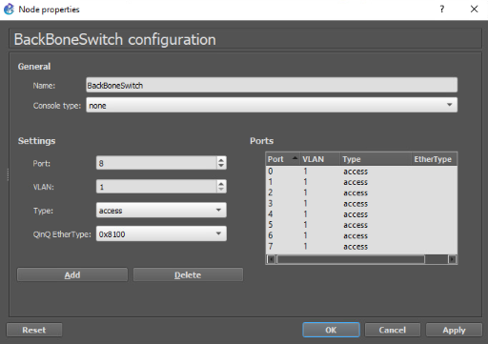
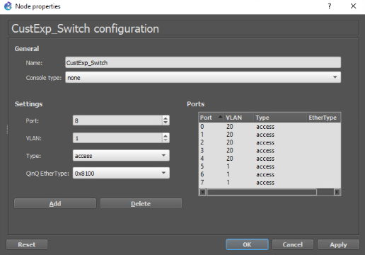
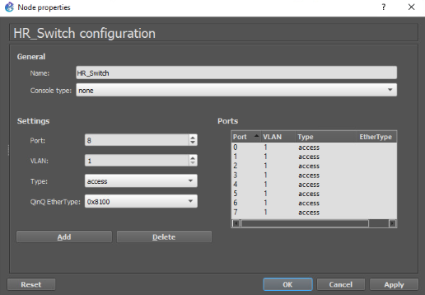
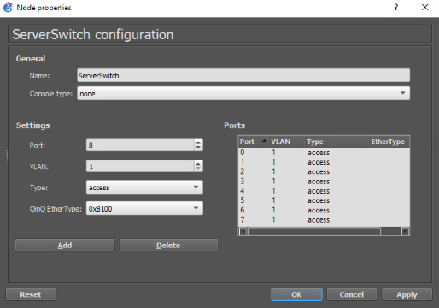

- Traffic Flow Configuration: Include screenshots of the following:
- Configure a firewall rule to allow port 80 HTTP from the WAN to the Web server.
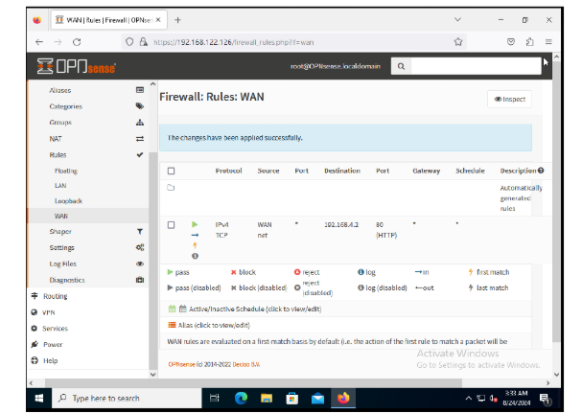

- Configure a firewall rule to allow port 443 HTTPS from the WAN to the Web server.

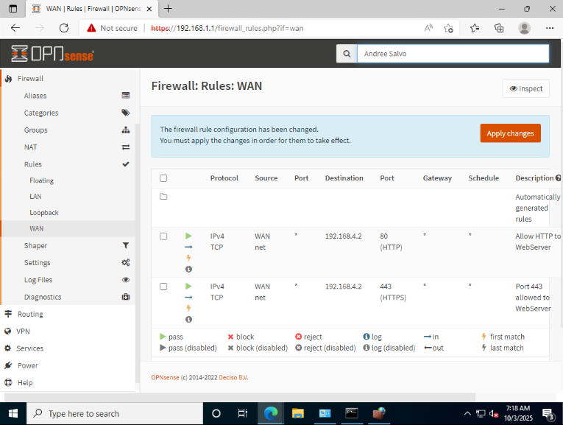

- Configure a firewall rule to block port 80 HTTP from the WAN to any other system.
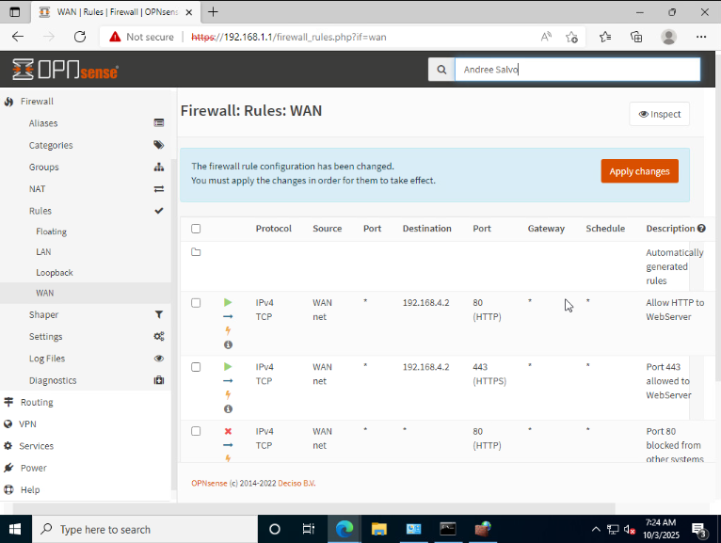
- Configure a firewall rule to block port 443 HTTPS from the WAN to any other system.

